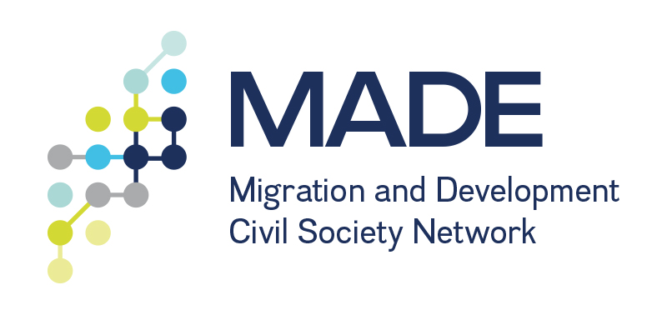

**20 November 2014, The Hague**



WEBINAR REPORT: Migration, Entrepreneurship and Development

This project is funded by the European Union. The contents of this document are the sole responsibility of the Implementing Organizations and can in no way be taken to reflect the views of the European Union.

**Written by:** C. Formson-Lorist,

ADPC MADE Coordinator

This Report captures the proceedings of the webinar on “*Migration, Entrepreneurship and Development*” hosted by the African Diaspora Policy Centre on 20 November 2014.

The webinar engaged a wide group of stakeholders in the field of migration and development on the topic of migrant/diaspora entrepreneurs as economic and social investors in the socio-economic development of their countries of origin or heritage.



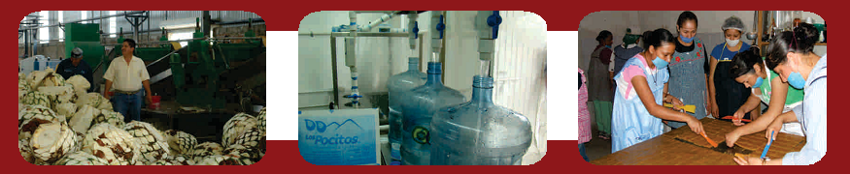



Photos: FEDZAC

# Table of Contents

Table of Contents 1

Background 2

Welcome and Introductions 2

Setting the context: the modus operandi of migrant/diaspora enterprises across countries and regions 3

DISCUSSION 4

Impact of migrant/diaspora entrepreneurship on job creation, skills development and corporate social responsibility 5

General impact 5

Experiences from Africa and Asia 6

Experiences from Latin America 7

DISCUSSION 8

Challenges and constraints faced by migrant/diaspora entrepreneurs in host and home countries 10

Best practices and lessons drawn from migrant/ diaspora enterprises across countries and regions? 12

Recommendations for specific policy considerations and practical action 12

Wrap up and Closing 13

Annex 1: Webinar Agenda 14

Annex 2: List of participants 15

*“The world gets smarter when people move. If you stop people from moving, you stop ideas from flowing.”*

*Migrant entrepreneur of Nigerian decent*

# Background

The Webinar on *Migration, Entrepreneurship and Development* was hosted by the African Diaspora Policy Centre (ADPC) in the context of the Civil Society **M**igration **A**nd **DE**velopment network (MADE) as discussed in more detail in the welcome session below. The panellist included academics and practitioners in the field of migration and development, with particular focus on diaspora and entrepreneurship. The panellist members in alphabetical order were:

* Mr. Abubakarr Bangura: Board member, African Diaspora Policy Centre, The Netherlansd
* Mr. Efrain Jimenez: Executive Director, Federación Zacatecana, United States of America
* Dr. Florian Täube: Professor, Solvay Brussels School of Economics and Management, Belgium
* Dr. Liesl Riddle: Associate Professor, The George Washington University School of Business, United States of America
* Ms. Stephanie Deubler: Technical Advisor, GIZ – CIM Project Migration and Development, Germany

Provided below is a summary of the proceedings of the webinar. Excluding the welcome and wrap up sessions, the Webinar was organised in 5 sessions and as such this Report takes a similar format.

# Welcome and Introductions

**Speaker:** Wies Maas, MADE Coordinator, International Catholic Migration Commission (ICMC)

Welcome and introductions were facilitated by Wies Maas, MADE Coordinator from the International Catholic Migration Commission (ICMC). In her remarks she briefed participants that the webinar was the first of several that will take place in the context of the MADE programme over the coming years. MADE is a global programme that aims to both build and connect civil society around the world to more effectively influence polices around migration and development from the national, regional and global level. MADE is about civil society networking, connecting through various platforms, advocacy and working with governments to change policy and practices to improve the wellbeing and dignity of migrants/diaspora and their families and communities. MADE adopts a holistic view to migration and development, starting from a human rights based approach.

The programme is organised at 3 levels: globally, regionally and thematically. Within the programme are 3 networks: in Asia, the Americas and in Africa that coordinates regional initiatives. In addition there are 3 thematic working groups. This particular webinar was held in the context of MADE's Working Group on migrants and diaspora for development. In addition, there is a working group on labour migration and recruitment and one on global governance of migration and development. At a global level MADE is coordinated by ICMC that has the responsibility to facilitate connectivity between the respective networks and thematic working groups.

MADE has emerged out of civil society coordinating within and around the Global Forum on Migration and Development (GFMD) that has met annually since 2007 and the recognition of the need to do more to ensure better follow-up, implementation, advocacy and monitoring of our global recommendations. Another key aspect is the civil society 5 year-8-point plan that was presented by a wide range of civil society groups to governments and the UN in 2013. The plan urges governments to work with civil society and migrants on 8 priority issues over the next 5 years. One of the eight points calls for better models and frameworks that facilitate the engagement of diaspora and migrant associations as entrepreneurs, social investors, policy advocates and partners in setting and achieving priorities for the full range of human development in countries of origin, heritage and destination. Consequently, the objective of the working group is to build up on this particular priority of the 5-year 8point plan. The webinar is therefore intended to contribute to the development of an implementation framework, policy recommendations and highlight inspiring practices taking place around the world that might be worth replication.

# Setting the context: the modus operandi of migrant/diaspora enterprises across countries and regions

**Presenter:** Abubakarr Bangura, Board Member, African Diaspora Policy Centre (ADPC)

This session of the Webinar focused on facilitating discussions on:

* What makes migrant/diaspora enterprises different?
* What is the nature of their operation?
* How they position themselves within the domestic environment in the homelands?
* To what extent does the transnational nature of migrant/diaspora entrepreneurship provide a comparative advantage over local enterprise?



***Abubakarr Bangura***

***Board Member, ADPC***

Mr. Bangura’s presentation was based on the framework depicted below developed by Context Masters, a Dutch training institution that specialises in training for migrants. In Figure 1 below the wide spectrum of diaspora enterprises that exist is depicted.

Based on this framework and drawing from the experiences of diaspora entrepreneurs in Sierra Leone, he highlighted that the endeavours of diaspora and migrant entrepreneurs combine profitable business initiatives with charity/social enterprises with low profitability both in The Netherlands and in Sierra Leone/in countries of origin.

**Figure 1: Types of Diaspora Businesses**

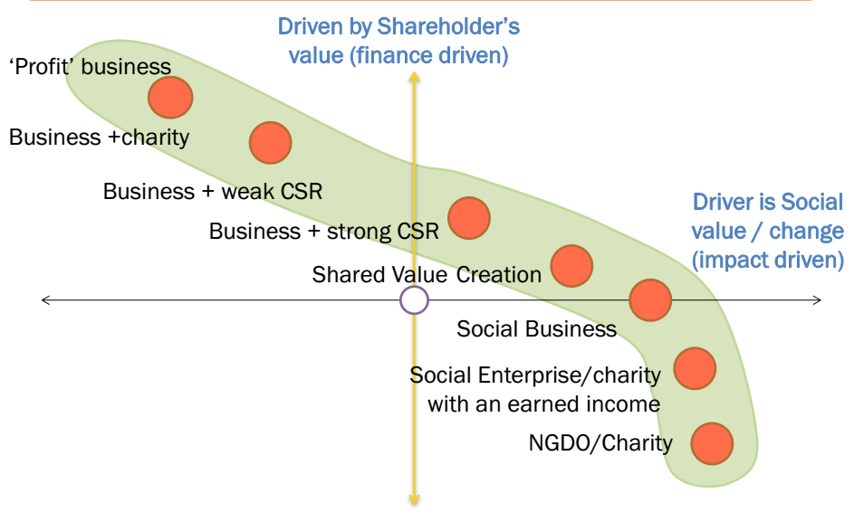

Source: Context Masters

In responding to the four questions raised above, he articulated further on :

**What makes migrant/diaspora enterprises different:** Drawing from the experiences of returnee migrants in Sierra Leone, migrant/diaspora entrepreneurs run businesses that require high education and start-up capital. Their focus is on hot spots and targeted sectors mainly agriculture and service sectors for instance ICTs to fill gaps in the supply chain which in many developing countries are weak.

**The nature of their operation:** They are organized through informal and formal business networks that facilitate connections to the supply chain. In Sierra Leone for example there are diaspora networks, business SMEs[1] that use their connections to lobby for policy change. Amongst diaspora in Sierra Leone, the connection to supply chain is strong. In Sierra Leone for example, a number of diaspora enterprises came together to provide transport to the mining sector by grouping together and used their unique advantage to penetration the market. In addition, as is the case elsewhere, diaspora entrepreneurs in Sierra Leone have powerful political orientation and being diaspora they remain sensitive towards the social impact of their interventions and ensuring community participation.

**How diaspora enterprises position themselves within the domestic environment in the homelands:** They are truly transnational and have cultural, social and financial capital that facilitates their undertakings. Diaspora entrepreneurs are risk oriented. They are often more willing to engage in business activities in high-risk or emerging markets. They also have the “First mover” advantage because they know where opportunities are, and make use of such opportunities when investing in or starting businesses in their countries of origin. Their role is often that of fostering niche markets. In addition they create employment.

**The extent to which the transnational nature of migrant/diaspora entrepreneurship provides a comparative advantage over local enterprise:** They facilitate innovation and knowledge transfers. Their unique nature enables them to pioneer the development of robust policy and spur economic development.

## DISCUSSION

Discussion based on the above presentation was:

**Q:** How can the Sierra Leonean experience be applied to other diaspora initiatives?

**R:** An interesting experience from Sierra Leone is within the context of the mining sector. What one mining company was doing to facilitate movement of its iron ore products was to source transport from Guinea. Seeing the threat and opportunity that this situation created, a group of UK based Sierra Leonean businessmen (10 in total) came together and each bought a vehicle. They then presented the 10 vehicles to the mining company in question. This eventually resulted in the company in question moving their business over to the group of Sierra Leonean business men. The team was able to penetrate the market because they were able to come together as a group. This kind of experience is definitely replicable in other countries within a short period of time. Here the partnership between different diasporans was the key to success.

# Impact of migrant/diaspora entrepreneurship on job creation, skills development and corporate social responsibility

**Presenters:** Florian Täube, Professor, Solvay Brussels School of Economics and Management

Stephanie Deubler, Technical Adviser, GIZ – CIM Project Migration and Development

Efrain Jimenez, Executive Director, Federación Zacatecana

In this session of the Webinar presentations were made by the three panellists’ named above. Provided below is a summary of the respective presentations. The full presentations are available from ADPC on request.

## General impact

Dr. Täube provided a general sense of the impact that migrant/diaspora entrepreneurs have on job creation and skills development. In doing so he highlighted that there is a growing number of migrants globally with diaspora forming the ‘4th largest country in the world’, with a population of approximately 250 million. In Germany for example, approximately 20 percent of the population are born in another country.



***Florian Täube, Solvay Brussels School of Economics and Management***

Currently substantial focus is provided to first generation migrants. Among first generation migrants, skills levels differ and are in part determined why they left their home country. The skills set of migrants/diaspora changes in the second generation, with different acculturation trajectories which influence the skills acquired. The differences between migrant generations differ within and across countries. There is need to undertake more research on the changing skills sets between first and second generation migrants/diaspora. Within this context, an understudied area is with regard to what influences the acquisition of education among second generation diaspora and how this affects their sense of identity, skills acquisition etc., and consequently entrepreneurship.

A typology of the different diaspora businesses that exist was presented from three different dimensions. First is the distinction between how diaspora entrepreneurs contribute directly and indirectly to job creation. Here it’s a case of migrants and their family versus outside jobs. Second is the distinction between home and host country jobs. Finally, is the distinction between ethnic and non-ethnic jobs. Examples provided regarding these various categories are:

* Direct host country ethnic: Chinese restaurant in a host location
* Indirect host country ethnic: targeted banking services, e.g. RIA financial dealing with remittances or a part of larger organisations targeting ethnic groups
* (In)direct home country ethnic: Suppliers for ethnic (food) shops
* Direct host country non-ethnic: Technology start-ups in Silicon Valley. These spill over into non family members as they grow and are not linked to ethnic products.
* Indirect host country non-ethnic: Various second generation businesses outside the typical ethnic business domain
* (In)direct home country non-ethnic: return entrepreneurs, often in technology; trading business etc.

In the context of the Cluster development Bangalore,[2] diaspora networks served as bridge connecting people. These were return entrepreneurs after years of exposure and external education systems, capital markets etc. Consequently they also served as a bridge for money. Exposure to markets has facilitated transfer of ideas to home countries. Within this typology it would be interesting for policy makers to look at what kind of job creation should be stimulated and what kind of job creation can be incentivised. Naturally home and host countries can only do this in their respective domains. How second generation migrants respond to these incentives etc., will depend in part to the acquisition of skills, which will also determine the support that can be provided to diaspora enterprises.

Further contact with Dr. Täube is possible at: [ftaube@ulb.ac.be](mailto:ftaube@ulb.ac.be)

## Experiences from Africa and Asia

Ms. Deubler’s presentation focused specifically on GIZ’s capacity building efforts as regards migrant/diaspora entrepreneurs of African and Asian origin. In doing so she provided participants with the rational, constraints and approach taken by GIZ within the context of the sector programme on migration and development.

 *Stephanie Deubler*

*Technical Adviser, GIZ*

The rational for the project is that migrants acquire capital, ideas, skills and networks abroad. This creates the potential for entrepreneurship and employment creation and where possible, options for reintegration. Constraining factors are the lack of information on migration, remittances, existing programs, available service providers for private sector development. A further constraint is the lack of investment interest in countries of origin (often due to lack of information). Last is the lack of networking structures that allow for exchange of contacts, ideas etc.

Two examples of GIZ interventions that started in 2010 were provided. One intervention is the provision of entrepreneurship training based on the toolbox MITOS.[3] The objective of the toolbox is to leverage the potential of migration for private sector development and provide complementary options for programs aiming at sustainable economic development.

In Uzbekistan there was the realisation that migrant families need to gain awareness on how to use remittances for varied initiatives. There was also the need to sensitise labour migrants on the options available to them. Consequently 2 MITOS tools-the Idea Generation for Migrant Investment Opportunities (tool 6) and tool 7 on business creation were used. Labour migrants and their family members were the main target of the training. However, the trainings also included participants from the local authorities, Central Bank, commercial banks, representatives of the Ministry of labour and social protection.

Another intervention undertaken by GIZ is advisory support for migrant entrepreneurs in Germany and countries of origin. Targeted at migrants in Germany, the intervention provides non-financial support (in Germany and the country of origin) to potential migrant entrepreneurs in partner countries. This intervention is currently taking place in Morocco, Cameroon, Georgia and Indonesia. The programme focuses on both first and second generation migrants with an interest in starting a business, and includes returnee and transnational entrepreneurs. Within the programme the phases of support are as depicted in Figure 2 below. Throughout close contact is maintained with partner countries.

**Figure 2: Programme Phases**

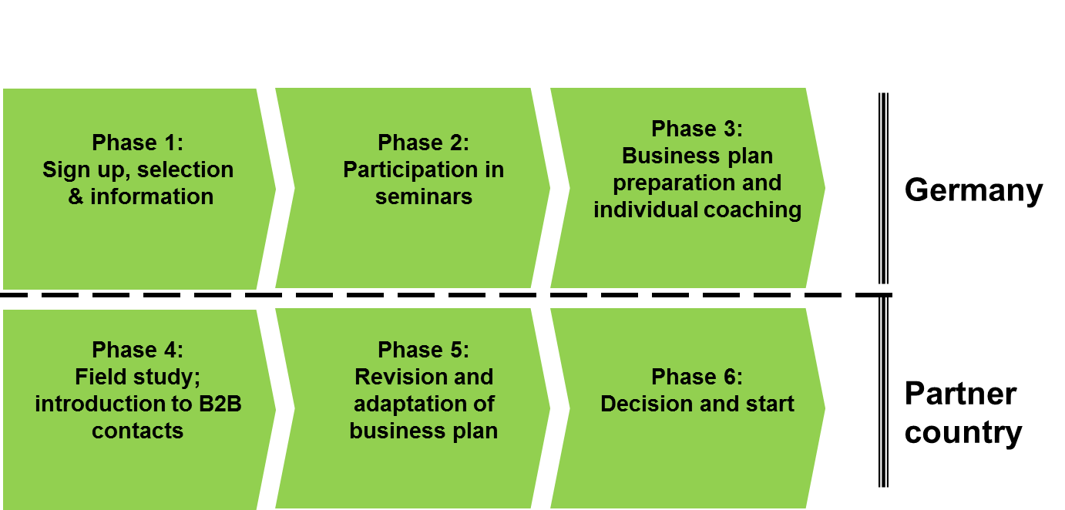

The experiences and the current outcomes of this programme in Morocco are presented in Figure 3 below:

**Figure 3: Programme outcomes in Morocco**

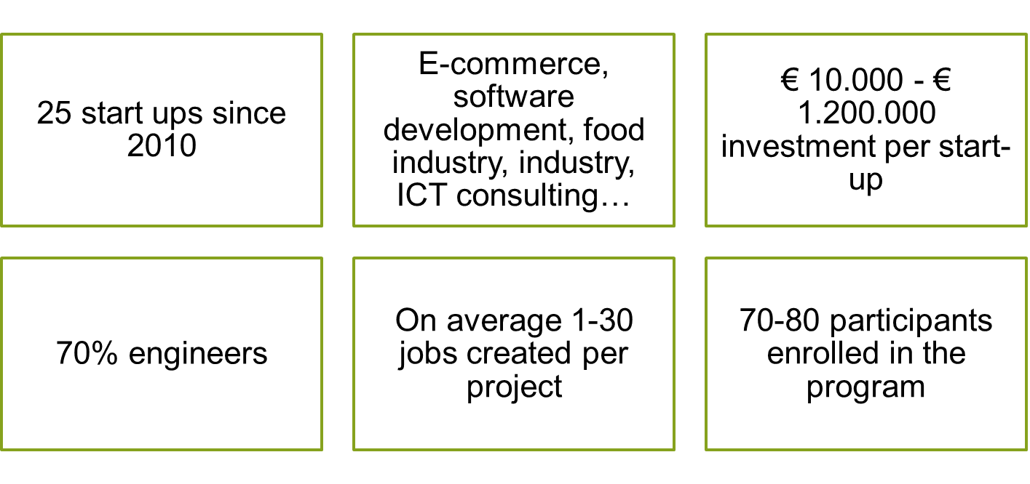

Further contact with Ms. Deubler is possible at: [stephanie.deubler@giz.de](mailto:stephanie.deubler@giz.de)

## Experiences from Latin America

The last presentation in this section was made by Efrain Jimenez who presented experiences from Mexico. In particular he shared the experiences of the Zacatecana diaspora in the US. Zacatecas is one of 31 regions of the Mexican Republic. The Federation Zacatecas (FEDZAC) hometown associations started in 1986 with 1 project supported through resources raised by migrants. Over the years FEDZAC has gained economic clout. Over a three year period, the organisations went from resource mobilisation levels of US$ 300,000 in 1999 to US$ 2.5 million by 2002. Over the years more than US$ 240 million has been invested in approximately 4,000 social projects such as schools, clinics, roads, portable water, paving streets, electricity, scholarships etc.

Success in the project has been possible in part because a mirror Federation in Zacatecas was created in Mexico to monitor, assist and help home communities strengthen their technical and entrepreneurial capacities. A system was designed that enabled follow up on each project promoting transparency and accountability. Between 1986 and 2002, 3 programmes were developed. In 1986, 1992 and 1999 the 1X1[4], 2x1 and 3x1 programmes respectively were created. In 2002 a 3x1 programme was developed throughout Mexico.



***Efrain Jimenez,***

***Federación Zacatecana***

The programme has grown over the years to the extent that in 2013 more than 32 projects were financed worth more than US$ 2.1 million. There is no final data for 2014 but indications are that there are far less projects than previous years in the case of Zacatecas.

**Text Box 1: Achievements of the Zacatecas Federation of hometown associations**

* 2004 Constitution modified in Zacatecas recognizing BiNacional status and assuring two seats to migrant leaders in congress on each election.
* 2005 Community centre created in the US with support of Zacatecas Gov’t
* 2009 Health Bi-National initiative created. (Berkley University, Gov’t and Zacatecan Federations)

**INVESTMENT PROJECTS**

* 2006 .- 3x1 program for productive projects from collective migrant investments. (minimum 8 migrant required to be eligible)
* 2009 .- 1X1 Program proposed by migrant organizations was created in partnership with central gov’t to finance entrepreneurial initiatives that would generate jobs and income for individual migrant and their families.
* 2010.- 2x1 Program proposed by migrant Federations created in Zacatecas with the participation of migrants, central and regional gov’t to promote productive projects (Individual micro business projects supported)

Further contact with Mr. Jimenez is possible at: [efrainjim@gmail.com](mailto:efrainjim@gmail.com)

## DISCUSSION

Based on the three presentations, discussions within this section were:

**Q1:** How can the development impact of migrant entrepreneurship be measured? Such evidence based research could help support demands to establish an enabling environment and additional resources for diaspora entrepreneurs.

**R1.1:** Impact is always hard to measure especially in the context of individual support for migrants - as in the case of Morocco. It is too early to talk about "impacts" in the project. However, GIZ has successfully supported the creation of 25 enterprises to date. There is full recognition of the fact that challenges exist and that impact is not only about creating jobs (employment creation) but also the innovative power (in terms of knowledge and technology transfer) of these enterprises; this is a tricky issue that GIZ is still trying to resolve. In Uzbekistan, for example, the programme team has set up a monitoring system to track the trainings provided and businesses started. This is however just a first step of towards the kind of impact assessments required.

**R1.2:** Within the interventions carried out in Mexico by FEDZAC,there has been no study assessing the impact of the various projects on the economy, migration and job creation. The program is 5 years old and not yet evaluated. However, the projects appear to be working well and are improved every year as new project rules are reviewed for use in the project for the next year.

**Q2:** How was the Government of Mexico approached and what sort of relationship exists? How was trust facilitated in the context of the projects carried out in Mexico given the high levels of corruption in Mexico?

**R2:** In this particular situation the projects were migrant initiatives as opposed to government. It was therefore essential as migrants to create partnerships with hometown associations. Then the groups joined together to form federations that would represent the state. When a big number of migrants are organised it is possible to demand a lot. In order to make demands the group had to carry out the projects themselves. The group had moral power more than the power of numbers. Through collective effort they financed projects even without government. Through this project portable water was sent to home communities where government would not invest because of a lack of resources, corruption etc. In the context of the 3x1 project, government was invited to participate at a later stage because it was their obligation.

In the 1x1 project the challenge was to overcome the unwillingness of migrants to invest. The security issue in Mexico is bad and very visible. However when migrants know that there are migrant leaders on the other side of the border handling the money and doing the administration, then people trust. If they know government is carrying out the administration then people would stop sending money. This has been the experience with many hometown associations, states and municipalities in Mexico. Many hometown associations stopped carrying out projects because the government was corrupt and not as good as it sounds. Consequently the loans for migrants to invest in these initiatives are resources administered by the migrants or their counterparts and not government. There are fewer projects this year because the government was not willing to invest because they knew that they would not get their “share” since the money would be sent directly to migrants.

**Q3:** Why has the Mexican experience not been replicated in Africa?

**R3:** To replicate the experiences in Mexico, there will have to be buy in by African governments. This will require meetings to sensitise African leaders on the importance of ensuring that these interventions have the required political backing. It is only with the requisite political commitment that these interventions can be realised.

# Challenges and constraints faced by migrant/diaspora entrepreneurs in host and home countries

**Presenter:** Liesl Riddle, The George Washington University School of Business

* What challenges and constraints do migrant/diaspora entrepreneurs face in host and home countries?
* To what extent do existing regulatory frameworks and policies in host countries promote and hinder the operations of migrant/diaspora enterprises in their countries of origin or heritage?
* How can an enabling environment conductive to flourishing and up-scaling migrant/diaspora enterprises be created in both the host and home country?

The segment on challenges was presented by Dr. Riddle. Building up on the presentation provided by Dr. Täube she articulated that the challenges faced by migrant/diaspora enterprises differ enormously. This is determined not only by the country of origin of migrants and diaspora, but extends to what generation of immigrant they are and the extent to which the organisation is truly a returnee enterprise or transnational in nature. Many diaspora ventures, particularly in their initial start-up phase are enterprises that operate in two continents simultaneously which presents different types of challenges and opportunities than in the context of a fully repatriated returnee who is operating in their country of origin and only periodically travelling. Consequently, the challenges vary by type of diaspora, by generation and type of enterprise in terms of being truly transnational or domestically focused in the country of origin or country of residence.



***Liesl Riddle***

***The George Washington University School of Business***

Diaspora enterprises often face challenges in countries of origin due to three major types of institutional weaknesses. The first is a lack of information analysis and advisors. In any kind of foreign investment situation, whether a diaspora enterprises or not, there is need for information gathering on the ground. There is often talk about diaspora entrepreneurs having good social connections and an understanding of markets in their countries of origin. At times this is true but it is difficult to truly understand an entire market in order for a diaspora enterprise to have all the social connections they require to get their business off the ground. Consequently it is important to recognise that diaspora enterprises also need relationship brokers in order to be successful, despite the fact that they come from that country and or have family and friends. This kind of relationship facilitates the market research necessary to undertake business with buyers, suppliers etc. Missing in many developing country markets are analysers, advisors and the right institutions that provide market research, human resource firms, management consultancy etc. This makes it more challenging to get businesses off the ground quickly.

The second type of challenge is the lack of credibility, answers and transition facilitators. It is often very hard to determine who to do business with when going back to home country markets. As a result a lot of businesses tend to be predicated on relationships that may not always be economic and efficient. Third, and most important, is the lack of risk capital providers. A lot of the capital in developing countries is tied up in terms of financing government projects or big projects with very little left for SMEs in general. It is particularly difficult for diaspora to gain access to risk capital particularly in countries of origin without having enough local collaboration in order to get the risk capital on the ground. They are then forced to turn to more transnational sources of capital. These are known institutional challenges. When bureaucratic delays and red tape are included in the mix of challenges that migrant/diaspora enterprises face on the policy front there is now call for “one-stop-shops” of support to diaspora enterprises. The idea being that returnee diaspora entrepreneurs would only need to go to one place to gain access to information about the market, brokering relationships and risk capital etc. Consequently, investment promotion agencies have now gotten into undertaking diaspora related activities. In addition various diaspora ministries have been formed and now engage in this area. There have also has business incubators in both countries of origin and residence trying to support diaspora enterprises. However these organisations face a number of challenges in efforts to provide support to diaspora enterprises. First is the issue of trust. Fundamentally migrant entrepreneurs often have great ideas to implement but are concerned about who to trust to help realise their dreams. The idea of cross sector partnerships are therefore very important whether government led or not.

Taking the discussion further, most types of government-led initiatives in this area tend to be most successful when they can identify opinion leaders within migrant associations who have diverse large networks in the enterprise community in countries of residence to really cultivate trust enhanced relationships. These opinion leaders are out there in social media, in diaspora organisation meetings speaking about the opportunities, resources etc. It is a much more legitimate and credible voice then if it comes only from the government. The idea of establishing partnership, in particular government cultivated networks of opinion leaders that are diverse in their opinions, backgrounds and experiences is therefore important. Representing transnational and returnee businesses as well as multiple generations and geographic interests is hard to do. This is a network strategy that diaspora organisations need to think through. Another challenge faced in terms of trust is the tremendous turn over seen in many organisations whether within migrant associations, business incubators, diaspora ministries or investment promotion agencies. The high turnover breaks trust and those that take over the various positions and try to solve existing problems have to engage in brand building exercises.

On the regulatory front, three main challenges exist with regard to freer flow of capital, greater voice and regulatory rights. First is the need for policy interventions to reduce the costs of remittances. A big issue, particularly in the US, advocating for congress to provide better opportunities for investors to engage in crowd financing. There are a lot of investors in the US who do not want or are unable to start-up businesses in their country of origin, but are willing and able to invest through crowd financing mechanisms back in migrant enterprise ventures in their countries of origin. However, the regulatory environment needs to change in order to provide the mechanisms through which to do so. An example of regulatory changes required relates to migrant deposits in countries of origin both in terms of local and foreign currency, and tying these deposits to decreases in interest rates when they apply for investment loans. Another would be changes to tax policies so diaspora enterprises can import required supplies and get the tax breaks needed to get their ventures off the ground. Yet another example is ensuring that the regulatory environment is conducive to the kind of matching programmes Efrain spoke about earlier.

The issue of voice is also important. A major obstacle to investment is the lack of voice in how businesses enabling environments develop in home countries. Equally important is addressing issues of dual citizenship or other types of citizenship status and even non-voting citizenship rights that at least protect property rights and allow migrant entrepreneurs, particularly those who are truly transnational, to ensure that their investments receive the same type of rights and respect that local investments receive.

Further contact with Dr. Riddle is possible at: [lriddle@gwu.edu](mailto:lriddle@gwu.edu)

# Best practices and lessons drawn from migrant/ diaspora enterprises across countries and regions?

Within the webinar best practices were shared in the discussion held on the impact of diaspora enterprises on job creation and skills development as captured above. Articulated above are experiences from Morocco, Uzbekistan and Mexico.

# Recommendations for specific policy considerations and practical action

**Moderator:** Abubakarr Bangura, Board member, African Diaspora Policy Centre

Within this section the discussions were directed towards articulating:

* Proposals for specific policy reconsideration
* Proposals for practical action in specific areas; for example: Action in specific areas by international organisations, government, the private sector and civil society that will do more to remove obstacles and create opportunities for migrants/diasporas to use their full potential for development of home countries.

General recommendations emanating from the various presentations and discussions were:

* Existing good practices need to be properly documented to enable evidence based interventions through sharing of best practices and lessons learned. For example Abubakarr Bangura and Gerd Junne are currently developing an on-line diaspora entrepreneurship training programme that will take place in Sierra Leone. A component of the training programme is focused on development of a toolbox. To avoid duplication, there will be collaboration with GIZ who has developed the MITOS toolbox. The MITOS will therefore be tested in Sierra Leone as well.
* Based on the discussion regarding the importance of trust, 7 key recommendations can be put forward, namely:
  1. go to home countries or countries of origin frequently;
  2. work through pilot project;
  3. share the risk of investments between diaspora enterprises and governments;
  4. establish partnerships especially with local organisations;
  5. listen to regional priorities;
  6. make sure that those who manage projects have the requisite skills to do so and;
  7. ensure that there is no duplication of existing initiatives in the region.
* Diaspora can also work with citizens in host countries to mobilise capital for investments in the homeland of diaspora.

Based on the various presentations and discussions, specific recommendations towards various actors were also put forward:

**Governments:** Based on the challenges that diaspora organisations face outlined above, governments should cultivate a diverse set of opinion leaders that spread the message about investment opportunities. Having governments issue clear policy and regulatory statements regarding entrepreneurship opportunities in countries of origin brings more credibility to information received by diaspora regarding investment opportunities . It is also important to ensure that the group of opinion leaders is diverse and is also able to articulate issues that may not necessarily be the key focus of government. The more voices the more credibility.

**Private sector:** Partnerships should be established between diaspora organisations and the private sector.

**Migrant/diaspora entrepreneurs:** Should seek to promote more partnerships and work with counterpart organisations in their home countries or countries of origin. In addition, effort should be made to establish formal diaspora associations etc., that provide dedicated full time professional support for diaspora entrepreneurship. At present a number of diaspora support interventions are run by volunteers who often have full time jobs.

**The academic sector:** Needs to be more involved in this area. There should be more research into the impact of existing diaspora enterprises on socio-economic development in home communities. In addition, there should be vigorous documentation of existing interventions.

Comic Relief in the UK is currently doing a scoping exercise to establish the kind of support diaspora would like as regards establishing socially conscious investments in Africa. Within this context there will be opportunities for Diaspora to get involved.

# Wrap up and Closing

Overall the webinar touched on a number of pertinent issues with regard to:

* Facilitating trust among participating entities
* Ensuring government commitment
* Facilitating changes to the regulatory and institutional environment
* The need for vigorous research and in particular impact evaluations and documentation of best practices for replication and lessons learned
* An enhanced understanding of the profile and nature of diaspora entrepreneurs and the sectors they occupy
* Better understanding of the transnational versus returnee dimensions of migrant/diaspora entrepreneur businesses
* The mechanisms through which migrant/diaspora entrepreneurs pull together capital to support initiatives undertaken
* The diverse challenges that diaspora entrepreneurs face in their varied contexts of operation.
* The importance of establishing a wide spectrum of partnerships
* The various training tools with which to equip diaspora with the requisite skills to run successful businesses.

In closing Mr. Bangura thanked all participants for their contributions and indicated that the policy recommendations emanating from the webinar session would be shared once developed.

# Annex 1: Webinar Agenda

|  |  |
| --- | --- |
| **Webinar on Migration, Entrepreneurship and Development** | |
| **Moderator** | *Abubakarr Bangura, Board member, African Diaspora Policy Centre* |
| **Panel** | * **Abubakarr Bangura:** Board member, African Diaspora Policy Centre * **Efrain Jimenez:** Executive Director, Federación Zacatecana * **Florian Täube:** Professor, Solvay Brussels School of Economics and Management * **Dr. Liesl Riddle:** Associate Professor, The George Washington University School of Business * **Ms. Stephanie Deubler:** Technical Advisor, GIZ – CIM Project Migration and Development |
| **Participants** | MADE Thematic working group, ICMC, Partner organisations |
|  | |
| 14:00-14:05 | **Welcome and Introductions**  *Wies Maas, MADE Coordinator, International Catholic Migration Commission* |
| 14:05-14:10 | **Setting the context: the modus operandi of migrant/diaspora enterprises across countries and regions**   * *What makes migrant/diaspora enterprises different?* * *What is the nature of their operation?* * *How they position themselves within the domestic environment in the homelands?* * *To what extent does the transnational nature of migrant/diaspora entrepreneurship provide a comparative advantage over local enterprise?*   *Abubakarr Bangura, Board member, African Diaspora Policy Centre* |
| 14:10-14:20 | **Discussion** |
| 14:20-14:35 | **Impact of migrant/diaspora entrepreneurship on job creation, skills development and corporate social responsibility**   * *Experiences in Africa* * *The Latin American experience* * *The experience in Asia*   *Florian Täube: Professor, Solvay Brussels School of Economics and Management*  *Stephanie Deubler, Technical Adviser, GIZ – CIM Project Migration and Development [on experiences in Africa and Asia]*  *Efrain Jimenez, Executive Director, Federación Zacatecana [on experiences in Latin America]* |
| 14:35-14:45 | **Discussion** |
| 14:45-14:50 | **Challenges and constraints faced by migrant/diaspora entrepreneurs in host and home countries**   * What challenges and constraints do migrant/diaspora entrepreneurs face in host and home countries? * To what extent do existing regulatory frameworks and policies in host countries promote and hinder the operations of migrant/diaspora enterprises in their countries of origin or heritage? * How can an enabling environment conductive to flourishing and up-scaling migrant/diaspora enterprises be created in both the host and home country?   *Liesl Riddle, Associate Professor, The George Washington University School of Business* |
| 14:50-14:55 | **Discussion** |
| 14:55-15:05 | **Best practices and lessons drawn from migrant/ diaspora enterprises across countries and regions?**   * Are there examples of exceptionally positive practices that can be shared for replication elsewhere?   *Open session* |
| 15:05-15:10 | **Recommendations for specific policy considerations and practical action**   * Proposals for specific policy reconsideration * Proposals for practical action in specific areas; for example: Action in specific areas by international organisations, government, the private sector and civil society that will do more to remove obstacles and create opportunities for migrants/diasporas to use their full potential for development of home countries.   *Abubakarr Bangura, Board member, African Diaspora Policy Centre* |
| 15:10-15:20 | **Discussion** |
| 15:20-15:30 | **Wrap up/recap of key insights gained from the panel discussion**  *Abubakarr Bangura, Board member, African Diaspora Policy Centre* |

# Annex 2: List of participants

|  |  |
| --- | --- |
| **Name and Organisation** | **Email Address** |
| Abubakarr Bangura, ADPC, The Netherlands | [abubakarr2000@yahoo.com](mailto:abubakarr2000@yahoo.com) |
| Liesl Riddle, The George Washington University, USA | [lriddle@gwu.edu](mailto:lriddle@gwu.edu) |
| Florian Täube, Professor, Solvay Brussels School of Economics and Management, Brussels | [ftaube@ulb.ac.be](mailto:ftaube@ulb.ac.be) |
| Stephanie Deubler, GIZ, Germany | [stephanie.deubler@giz.de](mailto:stephanie.deubler@giz.de) |
| Efrain Jimenez, Federación Zacatecana, USA | [efrainjim@gmail.com](mailto:efrainjim@gmail.com) |
| Elizabeth Hooijenga, ExDT&V, The Netherlands | [ehooijenga@hotmail.com](mailto:ehooijenga@hotmail.com) |
| Gerd Junne, The Network University (TNU),The Netherlands | [gjunne@gmail.com](mailto:gjunne@gmail.com) |
| Karen Campbell, Migrant Forum in Asia, Philippines | [mfa.karen@gmail.com](mailto:mfa.karen@gmail.com) |
| Tatcee Macabuag, Migrant Forum in Asia, Philippines | [mfa.karen@gmail.com](mailto:mfa.karen@gmail.com) |
| Sara Gallagher, International diaspora Engagement Alliance (IdEA), USA | [sara@diasporaalliance.org](mailto:sara@diasporaalliance.org) |
| Joe Frans, Next Generation Africa, Sweden | [joefrans@joefrans.se](mailto:joefrans@joefrans.se) |
| John K. Bingham, ICMC, Brussels | [bingham@icmc.net](mailto:bingham@icmc.net) |
| Wies Maas, ICMC, Brussels | [mass@icmc.net](mailto:mass@icmc.net) |
| Sophie van Haasen, ICMC, Brussels | [haasen@icmc.net](mailto:haasen@icmc.net) |
| Yéra DEMBELE, Federation des associations Franco-Africaines de developpement pour l'appui aux projets economiques (Fafrad - Economique) | [yera@fafrad.org](mailto:yera@fafrad.org) |
| ChiChi Nwosu, Crowland & Co,The Netherlands | [gazellecp@gmail.com](mailto:gazellecp@gmail.com) |
| Pius Kamau, Consortium of African Diasporas in the US (CADUS), USA | [kamaupk@gmail.com](mailto:kamaupk@gmail.com) |
| Jose Luis Gutierrez, The National Alliance of Latin American and Caribbean Communities (NALACC), USA | [jgutierrez@nalacc.org](mailto:jgutierrez@nalacc.org) |
| Stephen Deul, Diaspora Entrepreneurship, The Netherlands | [diasporaentrepreneurship@gmail.com](mailto:diasporaentrepreneurship@gmail.com) |
| Chibwe Henry, Diaspora for African Development (DfAD), UK | [chibwe.henry@dfad.org.uk](mailto:chibwe.henry@dfad.org.uk) |
| Bob van Dillen, Cordaid, The Netherlands | [Bob.van.Dillen@cordaid.nl](mailto:Bob.van.Dillen@cordaid.nl) |
| Sanne de Wit, Cordaid The Netherlands | [Sanne.de.Wit@cordaid.nl](mailto:Sanne.de.Wit@cordaid.nl) |
| Frans Wittermans, Kasidi Consulting, The Netherlands | [fwittermans@kasidi.nl](mailto:fwittermans@kasidi.nl) |
| Constance Formson-Lorist, ADPC, The Netherlands | [c.formson@diaspora-centre.org](mailto:c.formson@diaspora-centre.org) |
| Ahmed Nur, ADPC, The Netherlands | [a.nur@diaspora-centre.org](mailto:a.nur@diaspora-centre.org) |

1. Small and Medium Enterprises
2. Is research work that has been undertaken by the presenter over the years. The work looked at how the networking behaviour of diaspora clusters have contributed to the evolution of the Bangalore IT industry. See the following link for more information: <http://www2.druid.dk/conferences/viewpaper.php?id=5468&cf=32>
3. MITOS stands for Migration Tools Options for Sustainability
4. 1x1 programmes for investment in Mexico means that for every US $1invested by an individual migrant in Mexico it will be matched by a loan from the central federal government. The maximum loan amount is US $20,000.00 per project with a 0% interest at a 5 year term. This is payable to hometown association to be used in a 3x1 project.